They’re Getting Ready!

In the village of Zandvoorde (Zonnebeke), Belgium, they are working hard for an upcoming marble festival. Just a little longer and it's time, Tuesday August 6th from 2 pm!

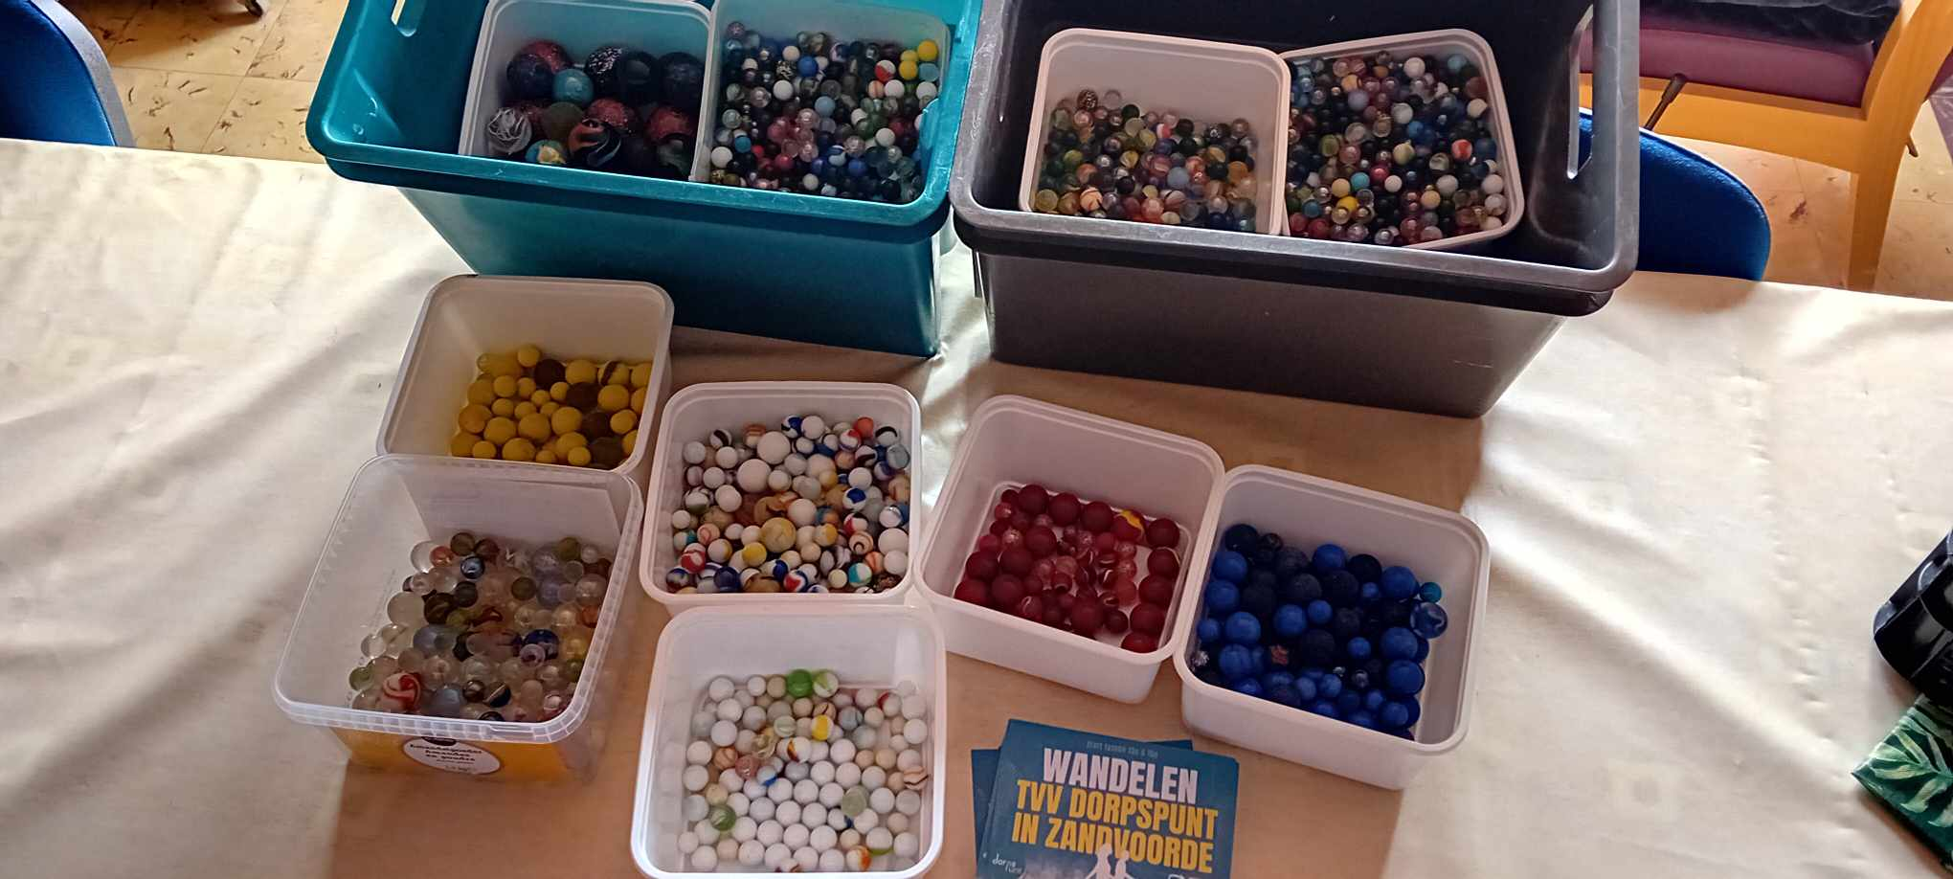

There will be lots of marbles, fun, and games. To read about the 2023 festival and see photos taken then, read our story